Minimum Stocking Standards, some of the Forest Management Assumptions on which they are based, and some of the realities that could inform their revision
Alex Woods, FLNRO, Smithers BC, (2012 06 19, NSC Summer Tour)
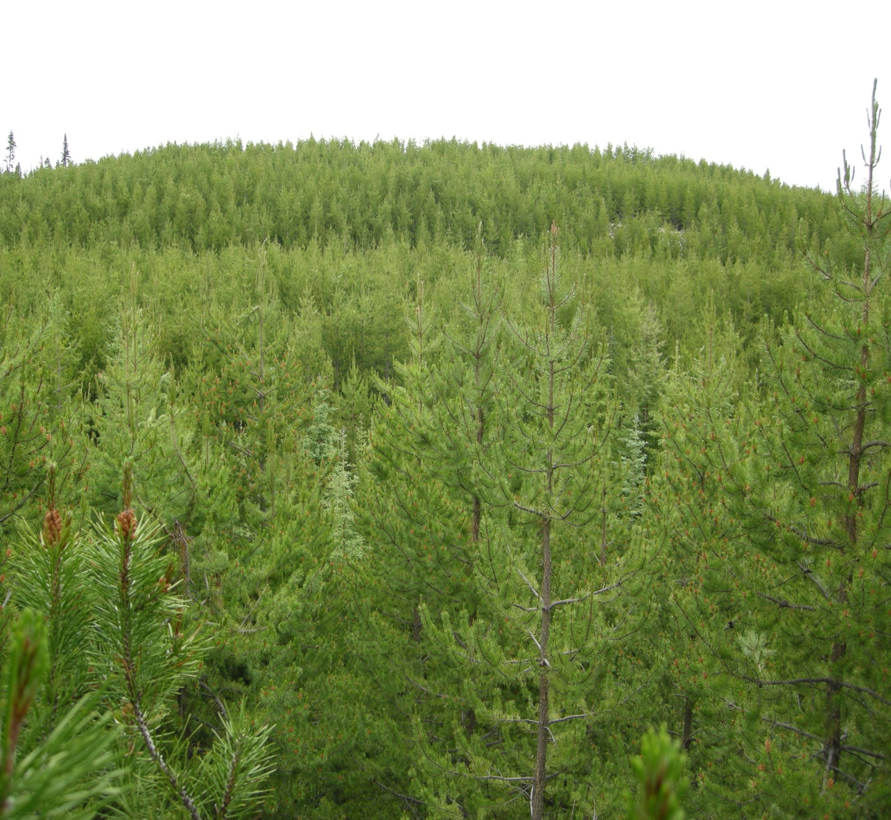
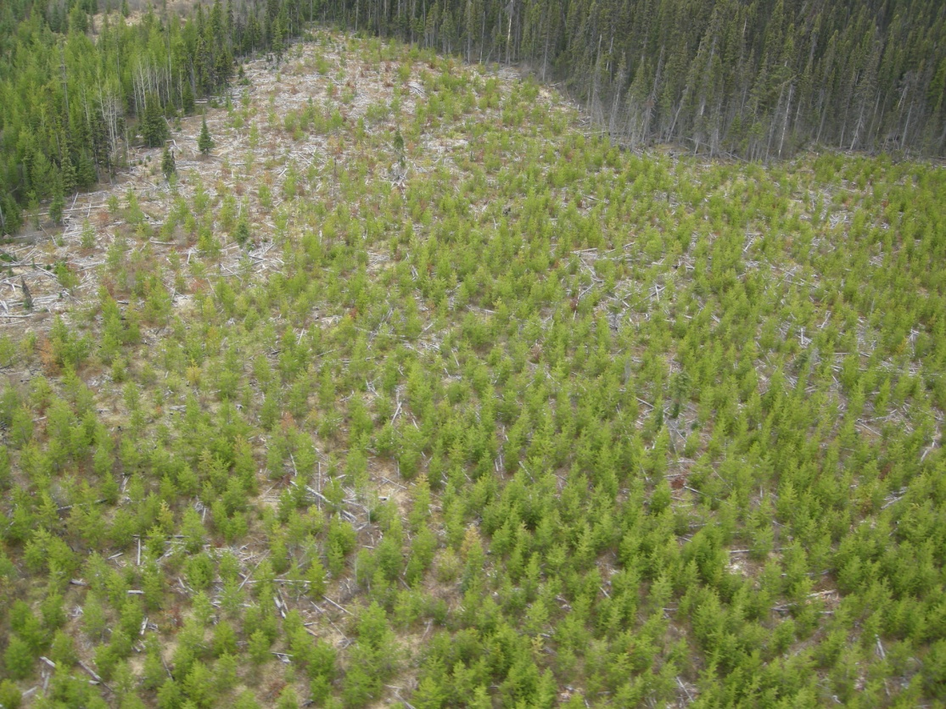
Minister's consideration of stocking standards [en. B.C. Reg. 580/2004, s. 24; am. B.C. Reg. 62/2005, s. 3.]
26 (3) The minister must approve the regeneration date, free growing height and stocking standards referred to in section 16 (3) if the minister is satisfied that
(a) the regeneration date and the standards will result in the area being stocked with ecologically suitable species that address immediate and long-term forest health issues on the area, to a density or to a basal area that, in either case,
(i) is consistent with maintaining or enhancing an economically valuable supply of commercial timber from British Columbia's forests, and
(ii) is consistent with the timber supply analysis and forest management assumptions that apply to the area covered by the plan on the date that the plan is submitted for approval, and
(b) the free growing height is of sufficient height to demonstrate that the tree is adapted to the site, and is growing well and can reasonably be expected to continue to do so.
(4) The minister must approve the stocking standards referred to in section 16 (4) if the minister is satisfied that the standards will result in the area being stocked with ecologically suitable species that address immediate and long-term forest health issues on the area, to a density or to a basal area that, in either case, is consistent with
(a) maintaining or enhancing an economically valuable supply of commercial timber from British Columbia's forests, and
(b) the timber supply analysis and forest management assumptions that apply to the area covered by the plan on the date that the plan is submitted for approval.
(5) The minister may approve the stocking standards referred to in section 16 (3) or (4), even though they do not conform to subsection (3) or (4) of this section, if the minister is satisfied that the regeneration date and stocking standards are reasonable, having regard to the future timber supply for the area.
So what does “(ii) is consistent with the timber supply analysis and forest management assumptions that apply to the area covered by the plan ...” mean? What changes in stand density are forecast to occur post free-growing based on TASS/TIPSY, the growth and yield model that is used in most every timber supply analysis in the province?
Growth and Yield Assumptions in Timber Supply Analyses:
TASS/TIPSY project mortality rates in managed stands to stabilize by age 15. Well-spaced density is forecast to decline over the rotation but slowly after age 15. To be consistent with TSR assumptions managed stands at age 25-30 should still have close to the same WS density as they had at free-growing because TSR assumptions are based on TIPSY.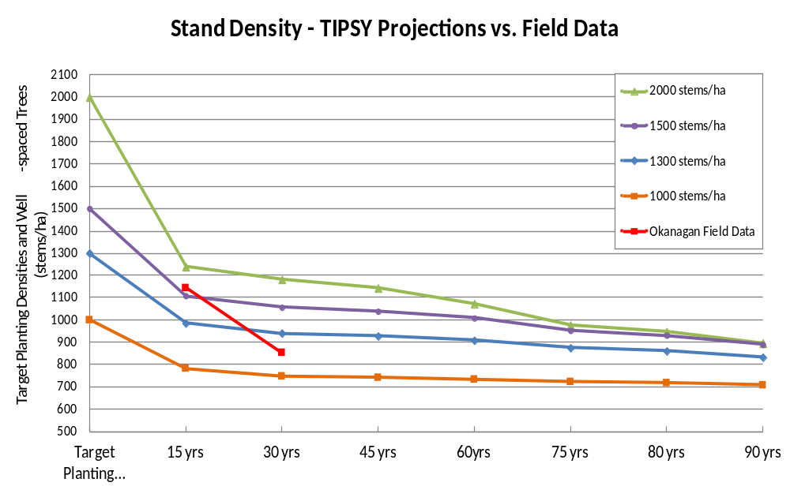 The fundamental principles of growth and yield assume that forest disturbances which attack larger crop trees, particularly mid-rotation, are rare exceptions. TIPSY assumes stable densities after age 15. Minimum densities are set for stands at free-growing which typically occurs at age 15 or earlier.

Langsaeters relation and the Thinning Response Hypothesis
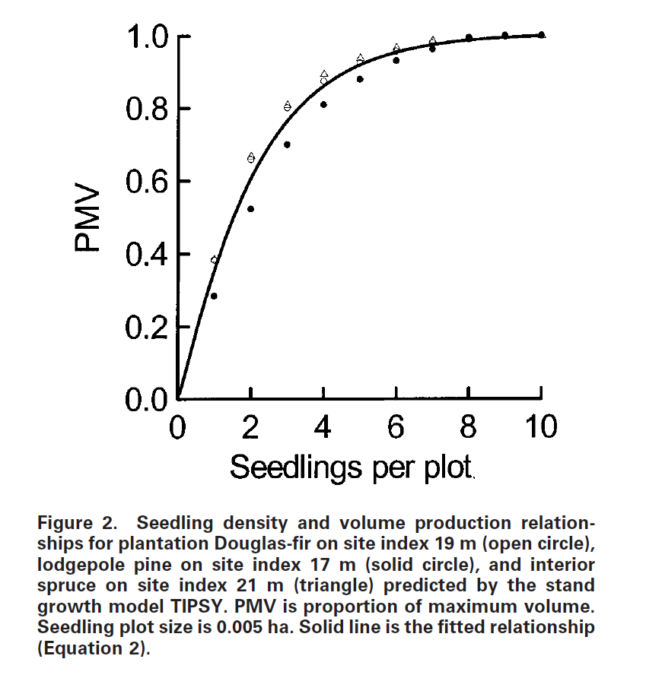
The thinning response hypothesis states that managed stand yields can be increased through stand density management. By concentrating the growth potential of a site on a limited number of stems the piece size and merchantable yield can be increased. Langsaeter’s relation is a basic tenet of the thinning response hypothesis which states that there is a minimum managed stand density above which projected harvest yields are stable and below which timber volume sharply declines. The closer one manages to this minimum density the lower the per hectare costs incurred for activities such as planting and stand tending, and the larger the trees grow.

TIPSY forecasts maximum potential volume at about 1600 wsph and forecasts a 30% decline in volume when well-spaced density drops from 1600 to 700 (Martin et al 2005). To be consistent with TSR assumptions and to avoid the decline in forecast volume associated with Langsaeters relation minimum densities should be closer to 1000 wsph.

Post-free-growing densities:
Managed stand densities are stable in some TSAs but in most of those assessed to date the WS density has declined by close to 20% (Woods et al 2011). In the Lakes TSA of the Nadina District assessments conducted by District staff show a decline of approximately 200 sph, from close to 1100 wsph to less than 900. Stands with 1100 wsph at age 15 should not drop to 900 wsph until age 90 according to TIPSY.
 | Biogeoclimatic zone |  |  |  |  |  | Total or mean
 | CWH | ESSF | ICH | IDF | MS | SBS | Total or mean
Number of stands | 58 | 44 | 74 | 3 | 27 | 60 | 266
Total density at free-growing survey (stems per hectare) | 2700 | 3860 | 5289 | 9250 | 4274 | 3544 | 4036
Total density at FREP survey  (stems per hectare) | 2947 | 2263 | 3596 | 4394 | 2908 | 3671 | 3190
Percent change in total density | +9%^{b} | –41% | –32% | –52% | –32% | +4% ^{b} | –21%
Target free-growing density | 900 | 1200 | 1200 | 1000 | 1200 | 1200
Minimum free-growing density threshold | 500 | 700 | 700 | 600 | 700 | 700
Well-spaced density at FREP survey (stems per hectare) | 792 | 886 | 840 | 813 | 890 | 1137 | 909
Free-growing density at FREP survey (stems per hectare) | 672 | 868 | 778 | 760 | 866 | 1078 | 846
Change in well-spaced density since declaration (stems per hectare) | +6 ^{b} | –154 | –241 | –351 | –252 | +35 ^{b} | –113
Change in free-growing density since declaration (stems per hectare) | –80 | –33 ^{b} | –138 | –116 ^{b} | –188 | +80 | –63
Numbers of stands with decreasing/increasing free-growing density | 37/21 | 24/20 | 56/18 | 2/1 | 20/7 | 19/41 | 158/108
ª These data all represent simple means. Positive differences (+) signify that the density has increased from declaration to time of survey; negative differences (–) signify that the total density has decreased.
^{b} Value not statistically different than zero (i.e., no statistically significant change).

So what is being planted? (Data source: RESULTS as of May 30, 2012, Prepared by Mei-Ching Tsoi)
Average of Planting Density | Column Labels
Row Labels | 2002 | 2003 | 2004 | 2005 | 2006 | 2007 | 2008 | 2009 | 2010 | 2011 | Grand Total
BWBS | 1,309 | 1,395 | 1,548 | 1,238 | 939 | 1,485 | 1,717 | 1,407 | 1,683 | 655 | 1,333
CWH | 1,020 | 1,074 | 994 | 1,185 | 1,017 | 968 | 853 | 792 | 901 | 921 | 968
ESSF | 1,358 | 1,438 | 1,188 | 1,222 | 1,256 | 1,186 | 1,531 | 1,625 | 1,464 | 1,317 | 1,323
ICH | 1,121 | 1,006 | 1,201 | 1,047 | 1,233 | 1,252 | 1,308 | 1,316 | 1,117 | 1,139 | 1,177
MH |  |  |  |  |  |  | 604 |  |  |  | 604
SBPS |  | 1,188 | 1,180 | 1,566 | 1,521 | 1,029 |  |  |  |  | 1,332
SBS | 1,483 | 1,470 | 1,446 | 1,449 | 1,516 | 1,445 | 1,451 | 1,328 | 1,380 | 1,374 | 1,442
SWB |  |  | 1,263 |  |  |  |  |  | 810 |  | 1,037
(blank) | 962 | 1,295 | 750 | 1,193 | 1,435 |  | 1,148 | 1,093 |  | 762 | 1,149
Grand Total | 1,437 | 1,445 | 1,417 | 1,423 | 1,490 | 1,424 | 1,439 | 1,323 | 1,362 | 1,355 | 1,421

Current minimum stocking standards are based on the assumption that few bad things happen to trees after age 15, and they assume that naturals will help fill in. Naturals will help but stands that rely on naturals should not be modelled as if they are managed stands following a regular planted distribution and the volume benefits that spatial distribution provides.

